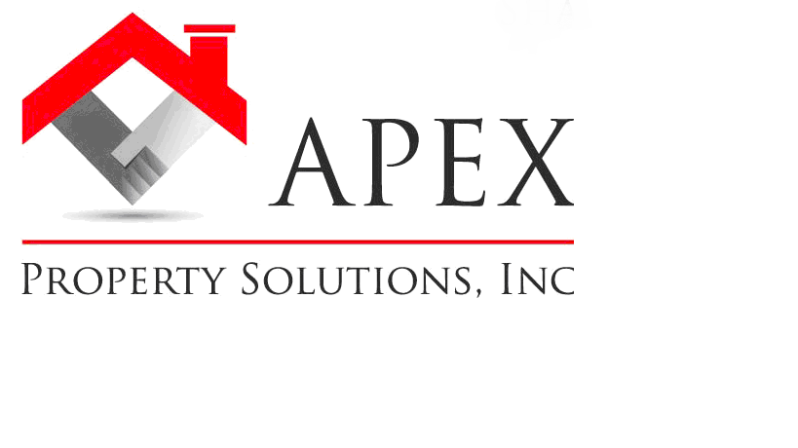

We Can Help You Buy A Home!

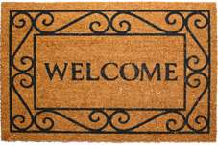
Buying a home can be exciting, stressful and puzzling, all at once. After all, you are making what’s likely to be the largest purchase of your lifetime. And your home is not only a financial asset; it’s a place for you to build your life and your family. Here at Apex Property Solutions our goal is to help members of our community have the opportunity to enjoy the benefits of owning a home! Whether you are in the market to buy your first home, upgrade to a larger home or purchase property as an investment, we will help make the process as smooth and seamless as possible.
Here are just some of the ways we can help you BUY A HOME:
- Get you pre-qualified quickly, and at no cost to you!
- We have numerous properties available and also have immediate access to homes before they are even put on the market!
- Help "Credit Challenged" buyers get qualified for a home.
- Our network of mortgage brokers, real estate agents, attorneys and other real estate professionals will be your resources as well!
- You get a clear-cut, honest transaction with a reputable company you can trust.
- We offer a Rent-To-Own program that enables you to lease the home of your dreams until you are ready to qualify for financing.
- Our company can help finance the purchase of your home! You get all the benefits and pride of owning a home, without requiring a bank to finance you.
- We will work hard to make your home buying experience smooth and successful!


You see truth be told, all real estate professionals are NOT the same. When you’re purchasing a home you need a local expert in your corner who’s working in your best interest. We believe that knowledge is what opens doors. With our knowledge and expertise you can feel confident in all aspects of the home buying process from choosing the right neighborhood to evaluating property value to negotiations to the closing!
Over the past few years alone we’ve helped hundreds of people make their dreams of real estate ownership come true. We’d be happy to provide you with numerous references from past clients. Please give us a call today at (860) 777-2259 so we can discuss your wants and needs in a home, and let you know how we can help make that happen.
Home Buyer Education

What People Are Saying About Us:
“We didn't know where to begin...we were not sure we could even afford a home on our own. After meeting with your real estate specialists, we got educated and excited! You took away all of our fears and really held our hands during the entire process. Because of you we are now homeowners! Thank You!!”
- Ben & Nancy Gorman

“Being in the mortgage business I know how complicated home transactions can be and that is why I have been so impressed with the way CT Homes, LLC does business. I have seen them solve some of the most difficult real estate problems that other investors and mortgage professionals would not touch. They are extremely professional and most importantly do what they promise. If you are looking to refinance, sell, or buy a home I would deal with them first!”
- Tom Wicker, Mortgage Broker
The home buying process can seem complicated, but if you take things step-by-step, you will soon be holding the keys to your own home! First, you need to know how and where to begin. We will answer all of the questions you have when deciding whether or not you are ready to buy a home. With all of the details involved in buying a home, we will be there to hold your hand and navigate you through every step.
Access To The Best Specialist In The Real Estate Industry
We work closely with a network of real estate professionals in order to provide you with access to the best-of-the-best in the industry. To assist you in the home buying process, we often leverage our close relationships in order to meet your needs. Our network includes:


- mortgage brokers,
- credit repair experts,
- attorneys,
- home inspectors
- private money lenders
- contractors
- moving companies
- and many more.

Knowing And Understanding Your Credit
It’s important to understand what credit is and how it affects you when buying a home. Together, we can find out what your credit score is and discuss what it says to lenders. We can show you how to get a FREE copy of your credit report and how to correct any errors you may find. If you have not-so-great credit, we also work with credit repair experts who can help you repair your damaged credit and put you back on the right path. We also have an excellent rent-to-own program that is beneficial to you during the transition…
Rent-To-Own Program
If you aren’t quite ready to purchase yet, you can really benefit from our rent-to-own program. The program was designed to help renters with credit issues who can’t yet qualify for a mortgage or don’t a large lump sum of cash available for a down payment. With our rent-to-own program, instead of just paying rent, your rent payments apply toward the purchase of a home! So you can to build equity, while repairing your damaged credit to qualify for a mortgage.
Choosing The Right Home

What People Are Saying About Us:

“I just wanted to say THANK YOU for the valuable information you shared with me. Because of your help I was able to save thousands when I bought my house. That money helped me to furnish my new home!
- Jamie Milano

“I’ve always wanted to get into real estate investing but never felt confident enough to do it. With your help I bought my first rental property with no snags. Thanks for helping my get started.”
- K. Crowley

“As a Real Estate attorney I deal with many difficult real estate closings and I have been extremely impressed with the way you have helped solve many of my client’s real estate problems. I extend my sincere gratitude to your company for your professionalism during our ongoing professional relationship.”
-Francis Lieto, Attorney, Lieto and Greenberg LL

There are many factors that come into play when choosing the right home. After discussing your needs and wants, we will familiarize you with the different housing types available to help you narrow your search and assure you’ll find what you’re looking for in a home. We will also determine how much house you can afford on your budget, so that we can help you find a home that suits both your lifestyle and your budget.
Save Money On The Purchase Of Your Home
Reducing the financial burden of a purchase of this magnitude is something every soon-to-be homeowner welcomes. With our intricate knowledge of the business, we will show you a variety of things you can do before, during, and after the closing to save up to $10,000 on the purchase of your home!
Investor Expertise
Property investing is a serious business. Whether you are a beginning investor or an experienced vet, the key to making money in real estate investing starts with BUYING RIGHT. This is the #1 mistake investors make all the time. We have helped landlords, rehabbers and wholesalers all across the state by arming them with the knowledge to make the BEST decisions to ensure a solid investment!

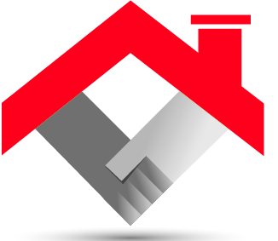
We Look Forward To Helping You Achieve
The Dream Of Home Ownership!

